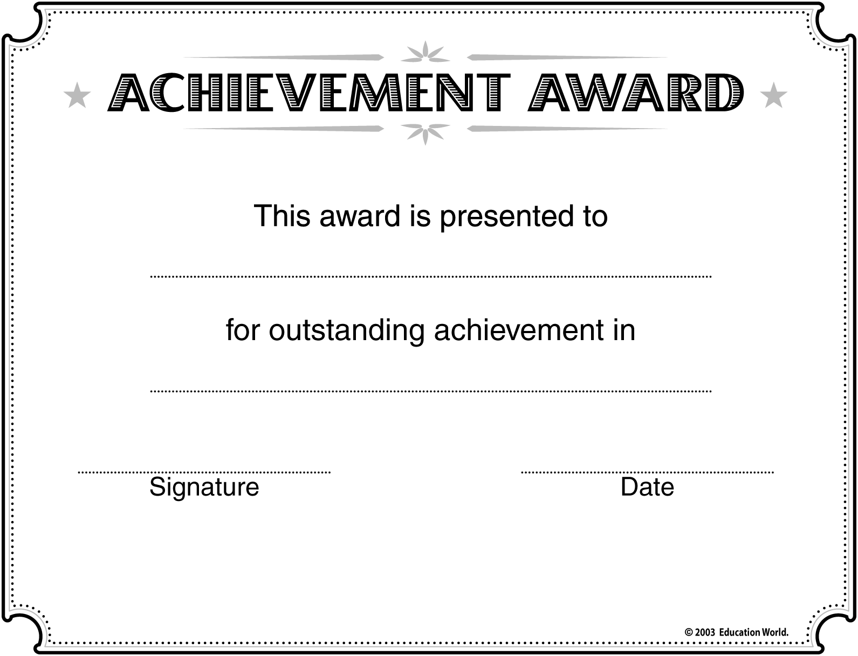
Insert NAME here
Insert SUBJECT here

Insert SCHOOL/CLASS NAME here


